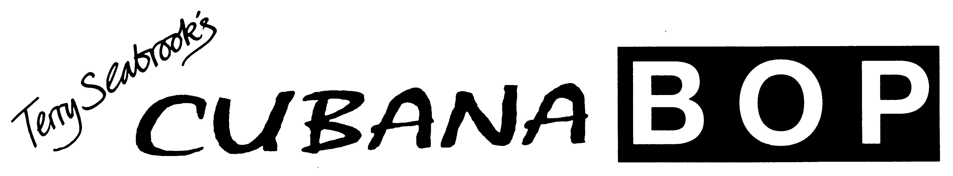

This word document contains biography material of 3 lengths: 100/200/450 words to suit your requirements.

Band Biography (100 words)

Cubana Bop are back with a new brand CD, Now Hear This, and the best Latin Jazz sounds this side of the Caribbean. Their first album, Can’t Stop Now, (with special guest Bobby Wellins) was featured regularly on Jazz FM and when the second album, The Story So Far, appeared Dave Gelly writing in The Observer said:

“With this impressive second CD, pianist Terry Seabrook’s Cubana Bop emerges as one of Europe’s top Latin bands. The brass is simply phenomenal”

Led by pianist Terry Seabrook with Ian Price (sax/flute) Graeme Flowers (trumpet/flugelhorn) Davide Mantovani (bass) Adam Riley (drums/timbales) Satin Singh (congas)

Band Biography (200 words)

Cubana Bop are back with a new brand CD, Now Hear This, and the best Latin Jazz sounds this side of the Caribbean. Their first album, Can’t Stop Now, (with special guest Bobby Wellins) was featured regularly on Jazz FM and when the second album, The Story So Far, appeared Dave Gelly writing in The Observer said:

“With this impressive second CD, pianist Terry Seabrook’s Cubana Bop emerges as one of Europe’s top Latin bands. The brass is simply phenomenal”

The band also has some new players in the line up:
Led by pianist Terry Seabrook with Ian Price (sax/flute) Graeme Flowers (trumpet/flugelhorn) Davide Mantovani (bass) Adam Riley (drums/timbales) Satin Singh (congas)

Cubana Bop was formed in 1995 out of a weekly Latin jam session at the infamous Casablanca club in Brighton. Past members include Byron Wallen, Raul D’Olivera, and Tristan Banks. They have performaned and recorded with top US musicians such as percussionists Pucho and Bobby Mattos and the flautist Dave Valentine.

During that time the band has performed at over 500 gigs at venues and festivals including Brecon, Edinburgh and London’s Jazz Café.

BAND BIOGRAPHY (450 words)

Cubana Bop was formed in 1995 out of a weekly Latin jam session at the infamous Casablanca club in Brighton and over the years the band members have included Byron Wallen, Raul D’Olivera, Gary Kavanagh, and Tristan Banks with performances and recordings with top US musicians such as percussionists Pucho and Bobby Mattos and the flautist Dave Valentine.

During that time the band has performed at over 400 gigs at K venues and festivals including Brecon, Edinburgh, London’s Jazz Café and The Festival Hall and Barbican Foyers.

Both of the first two CDs (Can’t Stop Now -1995 -featuring Bobby Wellins and The Story So Far -2000- produced by Snowboy) received rave reviews.

The new CD (Now Hear This!) features newcomers Davide Mantovani on bass, drummer Adam Riley and the brilliant young trumpeter Graeme Flowers. The music is all jazz with a strong Latin Afro-Cuban flavour featuring originals penned by Seabrook and a classic jazz standard, Jeanine by Duke Pearson.

Trumpeter Graeme Flowers graduated from the London College of Music in 2000 and has recorded and toured with Kyle Eastwood, John Dankworth, Snowboy, James Taylor Quartet, The Brand New Heavies, Martin Taylor, and the BBC Big Band.

Drummer and Timbalero Adam Riley has performed with Jamie Cullum, Katie Melua, Gary Husband, Don Weller, Alan Barnes, Alex Garnett, Mornington Lockett, Robin Jones and Azul.

Bassist Davide Mantovani arrived in London from his native Italy in 1991, and has played with some of the most illustrious Jazz and Latin artists around: Andy Sheppard, Ian Carr, Tony Remy, Gilad Atzmon, Antonio Forcione & Monica Vasconcelos. He has appeared at festivals in Edinburgh, Brecon, France, Italy, Spain, Turkey, Ireland and Luxembourg.

Ian Price plays both sax and flute and works with his own quartet as well as the Brazilian group Basiado and has appeared with Mike Outram, John Donaldson, Herbie Flowers.
Satin Singh plays congas and is as versed in Indian percussion as he is in Latin music. He began playing timbales in King Salsa as well as most of the Salsa bands in London. He has worked with Roberto Pla, Denys Baptiste, Jazz Jamaica, Matt Bianco and Down to the Bone.

Terry Seabrook (leader/piano) studied jazz at Eastman School in NY and started his career in 1985 touring Europe and the Middle East with US Jazz singer Joe Lee Wilson. His trio performs regularly in Brighton and London and has performed with Harry Edison, Sonny Stitt, Archie Shepp, and Jimmy Witherspoon. On the Latin scene Terry has worked with Robin Jones, Snowboy and Pucho. He is a busy Jazz piano teacher and appears as a tutor at The Jamey Abersold Summer School each year. He has written pieces for the Associated Board Jazz Piano syllabus and the Trinity Popular Piano syllabus.

